REDIS: Redis is a NoSQL database which follows the principle of key-value store. The key-value store provides ability to store some data called a value, inside a key. You can recieve this data later only if you know the exact key used to store it.

Redis is a flexible, open-source (BSD licensed), in-memory data structure store, used as database, cache, and message broker. Redis is a NoSQL database so it facilitates users to store huge amount of data without the limit of a Relational database.

Redis supports various types of data structures like strings, hashes, lists, sets, sorted sets, bitmaps, hyperloglogs and geospatial indexes with radius queries.

There are two main processes in Redis architecture:

* Redis Client
* Redis Server

These client and server can be on same computer or two different computers.

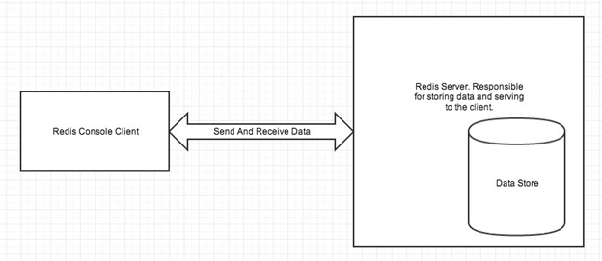

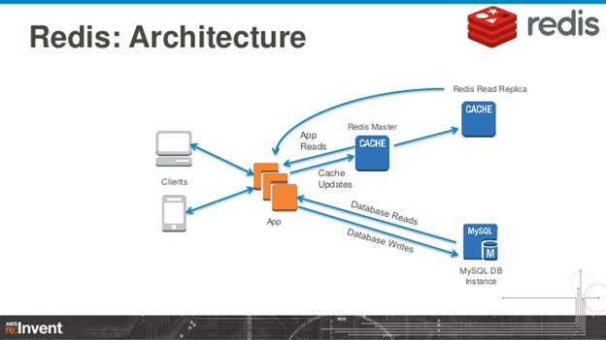

Start Redis Server

* Brew services start redis
* Redis-cli ping
* Redis-cli monitor

Interview Question

1. What is Redis in spring boot?

**Redis** is an open-source, in-memory key-value data store, used as a database, cache, and message broker. ... The **Spring** Data **Redis** framework makes it easy to write **Spring** applications that use the **Redis** Key-Value store by providing an abstraction to the data store.

2.How do I use Redis cache in spring boot?

@Cacheable in Spring Boot Data Redis

When applied at method level, then the annotated method's return value is cached with key as the method parameter. You can use other params such as cacheName, cacheManager, conditions with it. You need to annotate your spring boot main class with @EnableCaching to enable caching.